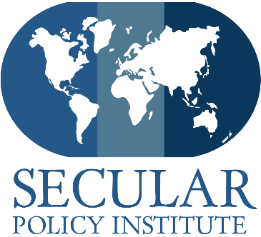
401 Ninth Street, NW, Suite 640
Washington, DC 20004
+1 202 430 1888
www.secularpolicyinstitute.net

August 21, 2015

Her Excellency Cristina Fernández de Kirchner
President of Argentina
Balcarce 840
Buenos Aires, Argentina

Ambassador Cecilia Nahón
Embassy of Argentina
1600 New Hampshire Ave, NW
Washington, DC 20009

Dear President Fernández and Ambassador Nahón:

The National Congress of Argentina just struck a blow to secular education in South America by passing a law that eliminates Education Law 1420 that created secular education. The General Common Education Law 1420 was integral to eradicating illiteracy in Argentina, but whenever attempts have been made in the past to alter it, the government always re-implemented it in its original form. The Secular Policy Institute and other undersigned coalition members are urging you, President Cristina Fernández de Kirchner, to veto this act and serve as a steward to protect secular education.

In 1884, Law 1420 established free, compulsory, universal, and secular education. Article 8 restricted religious education to outside regular school hours, by parental permission, and taught by a credentialed representative of its particular religion. Over the past 131 years, Argentina has seen the inception of public and private schools. In the 1990’s, the government decentralized public education, resulting in a division of nationally-administered schools governed by the many provinces. Regardless of Law 1420, several of the provinces have constitutional coverage for religious education; the recent act of congress would decouple secular requirements from schools altogether.

The encroachment of religion into government has been a recurrent problem with disastrous consequences. When Catholic Nationalists took over in 1943, they denounced all other religious and political doctrines as false, dissolved all other political parties and with Decree 18.411 declared Roman Catholicism to be the only religion to be taught in school. When this happened, students whose parents opted them out of morality classes were frequently bullied.

Giving a particular religious institution prerogative over education undermines the sovereignty of the state, especially the democratic process. When a regime and religious institution graft themselves upon each other political and religious discourse merge; to oppose the ruling party is to be a heretic, to oppose the church is to commit a crime.

A free, open, and democratic society cannot be sustained when identity-based, ideological privilege in schools is core-curriculum from day one. International Human Rights Conventions place preference on freedom of thought, conscience, and education unencumbered by such pressures. The Secular Policy Institute and the below listed organizations express our discontent with this measure, and our interest in preserving Law 1420, especially article 8, and to respectfully request a meeting between the government of Argentina’s diplomatic envoy to the United States and representatives from our organization, in opposition to religiously based education.

Yours Sincerely,
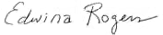

Edwina Rogers, CEO
Cell +1 202 674 7800
edwina@secularpolicyinstitute.net

